Intro: Value For Money – 4E Framework and PIN’s Approach
Given that measuring Value for Money is high on the agenda for international development actors, the practical guidance available is limited. PIN has developed two practical tools to answer the following questions:
Step-by-Step Guide: What is the cost of reaching each output and outcome of our project and are these costs justifiable?
VFM Systems Matrix: Are the correct systems and processes in place to ensure Value for Money?
PIN has based these tools on the 4E Framework of Economy, Efficiency, Effectiveness and Equity:
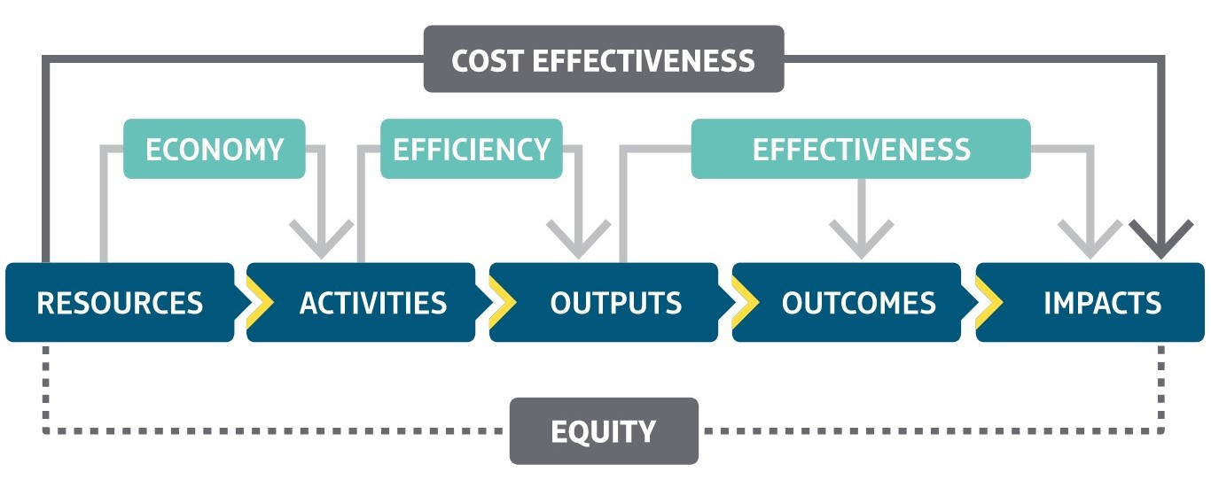
Adapted from DfID’s Approach to Value for Money, Department for International Development, July 2011, UK
It is essential that we do not misunderstand Value for Money as “doing things as cheaply as possible”. We use the 4Es to be able to evaluate and demonstrate the true value of our projects: that they are evidence-based (effective) and providing the best sustainable solutions for the most vulnerable (equity).
Economy: refers to the costs of the inputs needed for the project e.g. unit costs of staff, materials or equipment. Note that this includes both support costs and direct costs to project participants. We want the minimum cost for the inputs of the required quality.
Efficiency: refers to the cost of achieving each unit indicator at the output level i.e. what output you get for the inputs you put in. We want to maximise the given output for a given input.
Effectiveness: refers to whether the project’s outputs will translate into the project’s outcomes and at what cost. It requires a project’s Theory of Change to be evidence-based.
Equity: refers to whether the project is addressing social or economic disparity. It is a cross-cutting principle to consider throughout a VFM analysis.

Step-by-Step Guide: What is the cost of reaching each output and outcome of our project and are these costs justifiable?
The Step-by-Step Guide leads you through the calculations for:
- Evaluating Economy by reviewing the unit costs, identifying the key cost-drivers and describing the systems you have in place to maximize economy
- Developing and analysing quantitative VFM indicators of Efficiency, an example could be: 1 teacher trained in Active Learning Methods will cost 40 EUR.
- Developing and analysing quantitative VFM indicators of Effectiveness, an example could be: 1 student achieving a 10% improvement in attainment will cost 85 EUR.
- Considering Equity throughout.
If you would like to use this guide during the planning/proposal stage, you will need the logical framework and budget. In the past, project budgets have not divided support costs between the different outputs. This is now needed to generate VFM indicators and you can use our VFM-budget template that does most of the calculations for you. If you would like to assess a project’s VFM during or after a project, you will need a document of actual spending.

VFM Systems Matrix: Are the correct systems and processes in place to ensure Value for Money?
The VFM Systems Matrix can be used at the proposal stage as checklist of items to be considered during identification and planning or during project implementation as a self-assessment tool or a tool to be used by a project evaluator. It requires the review of the project documents, internal procedures as well as discussions with program and support staff. The Matrix can be used jointly with the step-by-step guide so that a holistic VFM analysis can be conducted.
This qualitative tool presents project management teams and evaluators a method for assessing the Value for Money using the "4E" categories: Economy, Efficiency, Effectiveness and Equity. The analysis of each "E" is divided into sub-categories of the different stages of a project:
- Identification and Planning
- Implementation and Monitoring
- Evaluation and Learning
A score is calculated for each of the 4E's and there is space to provide a narrative summary of the findings.

